Electric Jug

Name ___________________________ Sheet GT.P.9.145

The challenge

The challenge in this activity is to try to increase the temperature of 200 mol of tap water as much as possible in five minutes using the equipment provided.

The equipment available to your group

A 12 volt power pack, leads with alligator clips, two coils of nichrome wire (one thicker than the other), a 200 mol beaker, a thermometer, a light globe, a stopwatch and a measuring cylinder. .

1. Work in groups and spend five minutes designing your experiment.
You must include the light globe in your circuit to prevent the power pack from over heating.

2. Draw a circuit diagram to represent the circuit you have decided to use.

3 Carry out your first trial experiment and record your results in a table.

Trial | Rise in temperature after five minutes ºC
1
2

4. List ways that you could improve your design.

- Carry out your second trial experiment and record your results in the above table.

Name ________________________________

6. Write a few sentences to summarise what you discovered by doing this experiment

Electric kettles and jugs in the home work on the same principle as the electric jug you have designed.
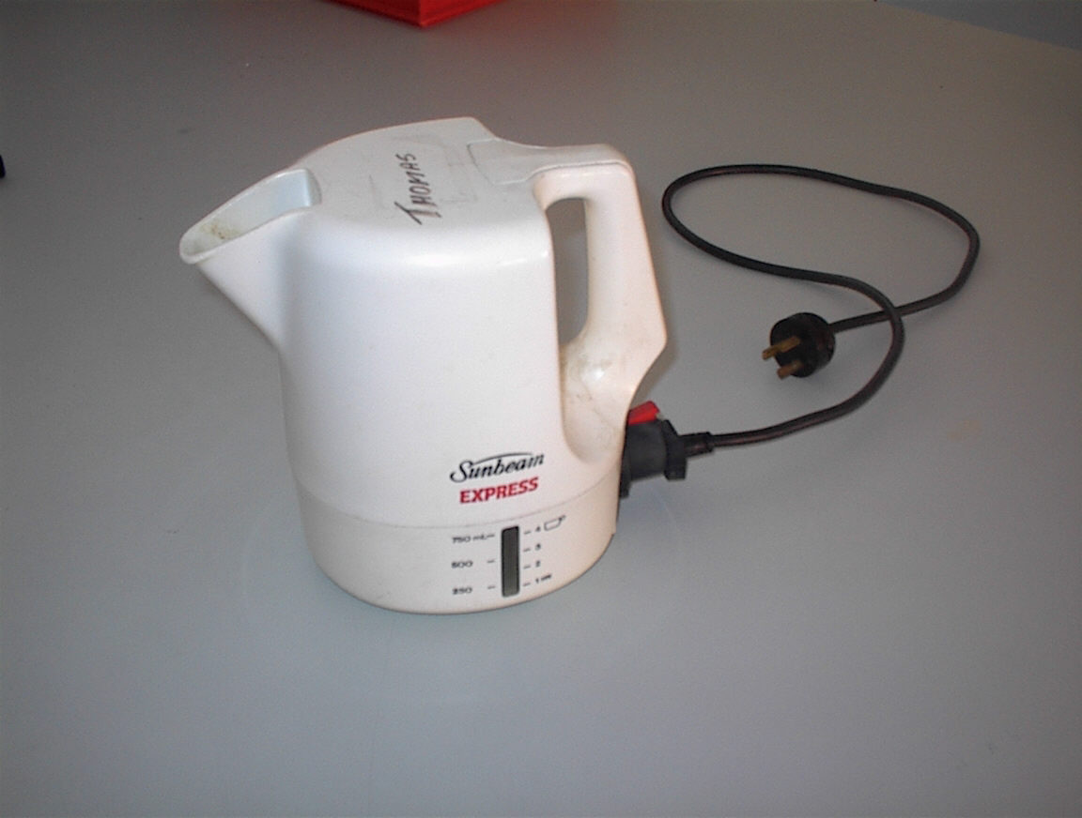

7. List two reasons why thin wire is wrapped in coils around the ceramic support in an electric jug.

8 Why do you think the jug’s body is ceramic or plastic and NOT metallic?

9 Why is nichrome wire rather than copper wire more likely to be used?

